**Assignment 3 - Group**

**Due:** Saturday, 23 July 2022, 11:59 PM

**To do:** Make a submission

**Create Moodboards**

**GROUP ASSIGNMENT**

***(Find more details in the e Class announcement section)***

As a designer, it’s always exciting when a client says “Let’s start from scratch.” You are the unicorn, the holy grail, in other words, a designer’s dream client. But this is where your project can get into trouble. Without a framework, there’s a high chance your team is presented with a design that neither represents your voice nor (and more importantly) speaks to your target audience.

The Learning objective of this assignment is to create a consistent UI design framework for our future App. We will create a moodboard to evoke a specific emotion or style within the design parameters of the **SoundPlay Music App**, giving the design team a visual path forward when creating the app. In a real-world setting, the mood set will be applied to the layouts once the user experience approach is approved and those layouts will be carried forward into development.

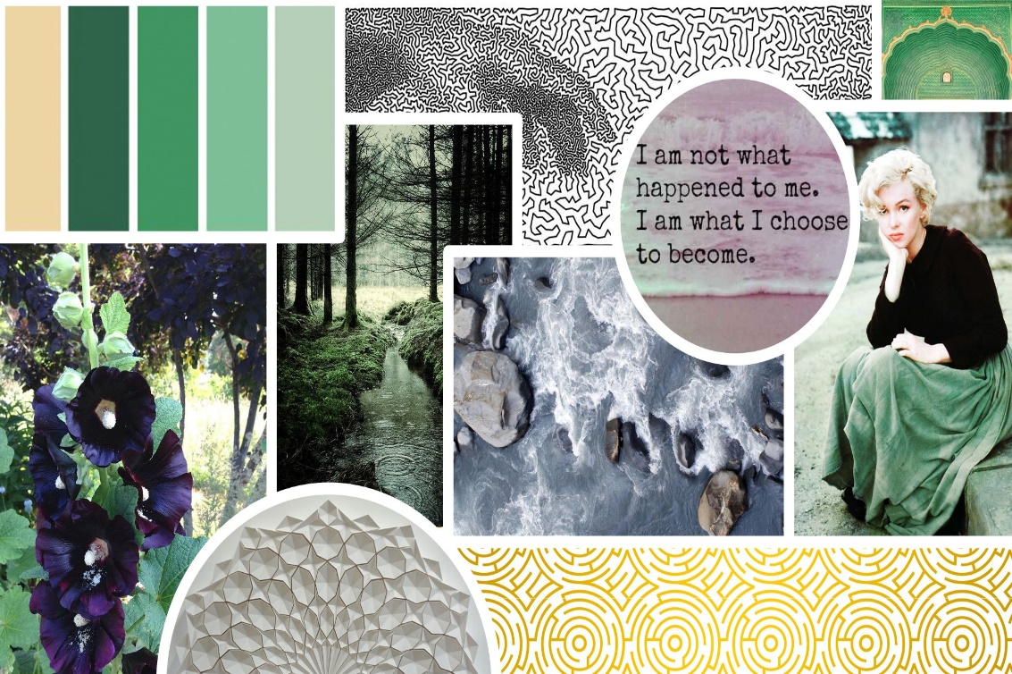

(image source: [99Designs](https://99designs.ca/blog/tips/how-to-create-a-mood-board/))

A **moodboard** is a collection of images put together that intend to communicate a concept or style. Clear communication is an integral part of the UI design process. Moodboards are a great tool in doing so as you and your client collaboratively build towards the design direction of your project.

Do not forget to re-visit your and your group member's **Design Inception Sheets (Assignment-1)** before starting working on the moodboard. For this assignment, you are not required to update or redo them but feel free to do so if you prefer.

*Read the****Evaluation Criteria****at the end of this page to see how this assignment will be graded!*

Using the [Pinterest board](https://help.pinterest.com/en/business/article/create-a-board) (<https://help.pinterest.com/en/business/article/create-a-board> ), [Canva](https://www.canva.com/) (<https://www.canva.com/> ), or any other platform of your choice, assemble a Moodboard that expresses the mood & design of the **SoundPlay Music App**.

Add the following elements to your [moodboard](https://youtu.be/QLTbT2bqsj0) (<https://www.youtube.com/watch?v=QLTbT2bqsj0> ): Patterns + Textures, Design Inspiration, Colour Inspiration, Font Inspiration, Photography (architecture, nature, abstract, etc)

**Some Helpful Resources**

How to create a beautiful moodboard

<https://www.canva.com/learn/make-a-mood-board/>

How to Create a Moodboard with Canva + Pinterest

<https://www.bearista.co.za/blog/how-to-create-a-moodboard-with-canva>

How To Make a Moodboard in Photoshop - Basic Tutorial

<https://www.youtube.com/watch?v=i1Zc-chHwWk>

**Submission guidelines:**

* Submit **ONE Moodboard** either an image, PDF or share the Google Doc link on eClass assignment section;
* One group member will submit on behalf of the whole group.

**Evaluation Criteria:**

* **Organization and Clarity**: The layout and space utilization is organized, is simple, efficient, and clear. Visual elements are arranged and grouped together whenever required. Giving the design team a clear visual path forward when creating the app.
* **Colour Schemes & Harmony:** being able to apply the elements and foundations of colour theory and psychology in creating a palette that enhances both the experience, style and theme of the app.
* **Images**: are representing a powerful but relevant message; images are coherent with the overall theme and colour schemes
* **Human-Centered:** being able to identify the elements that support and enhance the user experience (mood from design inception) the interface design offers.
* **Focused:** Project clearly establishes and communicates a goal (whys from design inception), creating suggestive and explicit directional cues for conversion.
* **Consistency**: Ensuring that overall style, textures, colours, typography, etc, and layout are consistent and coherent with the design inception elements.

**Rubric:**

Excellent = 4, Good = 3, Fair = 2, Needs Improvement = 1